**Bullet list:**

1)

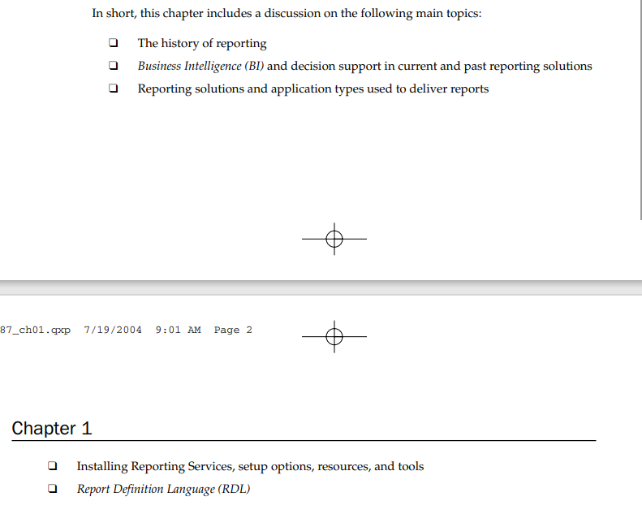

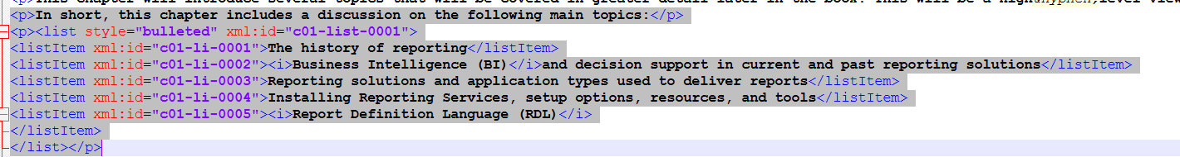

<p>In short, this chapter includes a discussion on the following main topics:</p>

<p><list style="bulleted" xml:id="c01-list-0001">

<listItem xml:id="c01-li-0001">The history of reporting</listItem>

<listItem xml:id="c01-li-0002"><i>Business Intelligence (BI)</i>and decision support in current and past reporting solutions</listItem>

<listItem xml:id="c01-li-0003">Reporting solutions and application types used to deliver reports</listItem>

<listItem xml:id="c01-li-0004">Installing Reporting Services, setup options, resources, and tools</listItem>

<listItem xml:id="c01-li-0005"><i>Report Definition Language (RDL)</i>

</listItem>

</list></p>

2)

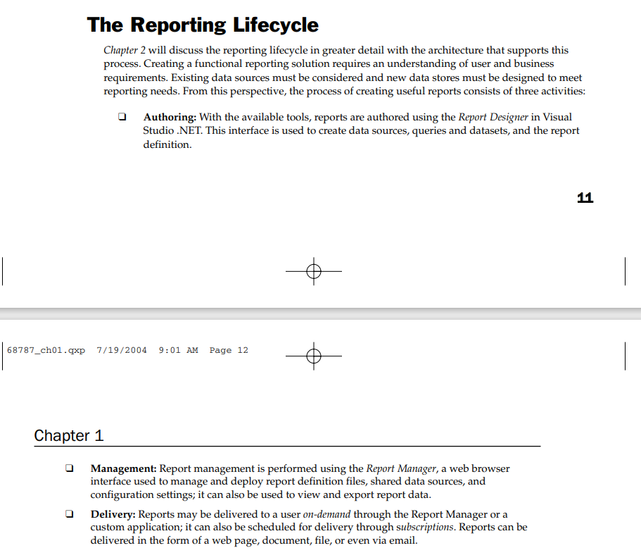



<p><list style="bulleted" xml:id="c01-list-0002">

<listItem xml:id="c01-li-0006"><b>Authoring:</b>With the available tools, reports are authored using the <i>Report Designer</i>in Visual Studio .NET. This interface is used to create data sources, queries and datasets, and the report definition.</listItem>

<listItem xml:id="c01-li-0007"><b>Management:</b>Report management is performed using the <i>Report Manager</i>, a web browser interface used to manage and deploy report definition files, shared data sources, and configuration settings; it can also be used to view and export report data.</listItem>

<listItem xml:id="c01-li-0008"><b>Delivery:</b>Reports may be delivered to a user <i>on&hyphen;demand</i>through the Report Manager or a custom application; it can also be scheduled for delivery through s<i>ubscriptions</i>. Reports can be delivered in the form of a web page, document, file, or even via email.</listItem>

</list></p>

3)

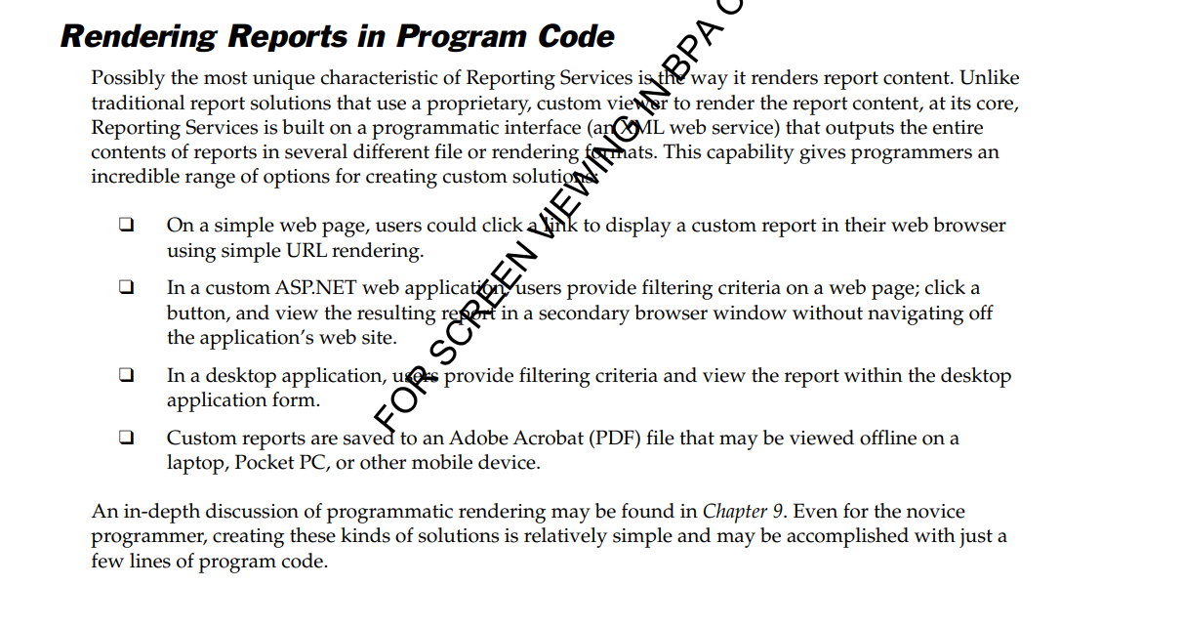



<p><list style="bulleted" xml:id="c01-list-0003">

<listItem xml:id="c01-li-0009">On a simple web page, users could click a link to display a custom report in their web browser using simple URL rendering.</listItem>

<listItem xml:id="c01-li-0010">In a custom ASP.NET web application, users provide filtering criteria on a web page; click a button, and view the resulting report in a secondary browser window without navigating off the application&apos;s web site.</listItem>

<listItem xml:id="c01-li-0011">In a desktop application, users provide filtering criteria and view the report within the desktop application form.</listItem>

<listItem xml:id="c01-li-0012">Custom reports are saved to an Adobe Acrobat (PDF) file that may be viewed offline on a laptop, Pocket PC, or other mobile device.</listItem>

</list></p>

**Numbered List:**

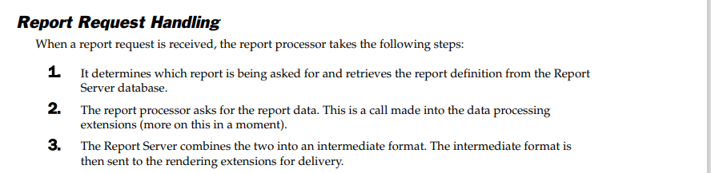



<p><list style="1" xml:id="c02-list-0006">

<listItem xml:id="c02-li-0027">It determines which report is being asked for and retrieves the report definition from the Report Server database.</listItem>

<listItem xml:id="c02-li-0028">The report processor asks for the report data. This is a call made into the data processing extensions (more on this in a moment).</listItem>

<listItem xml:id="c02-li-0029">The Report Server combines the two into an intermediate format. The intermediate format is then sent to the rendering extensions for delivery.</listItem>

</list></p>

**Nested List:**

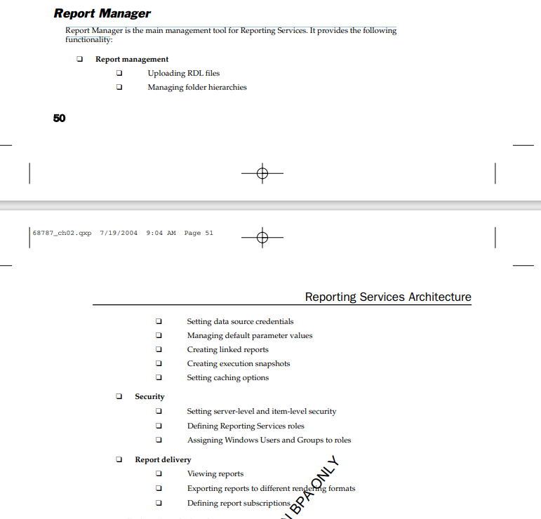

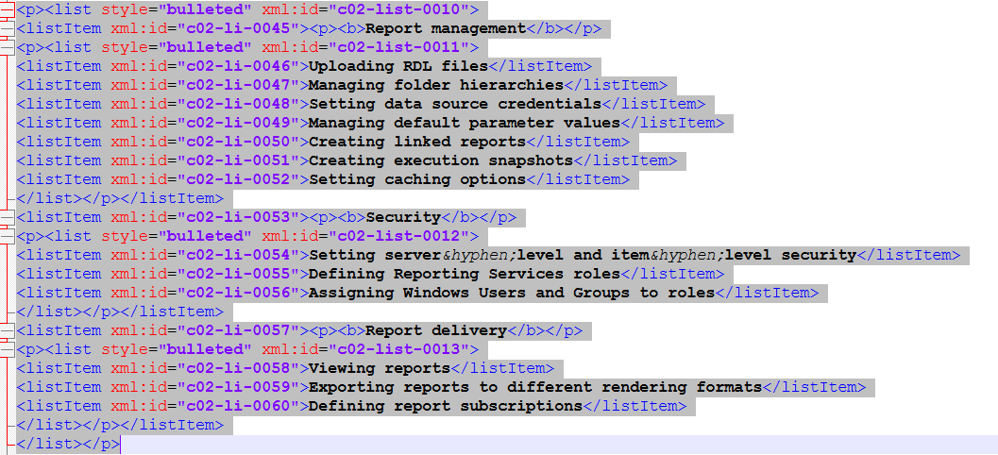

<p><list style="bulleted" xml:id="c02-list-0010">

<listItem xml:id="c02-li-0045"><p><b>Report management</b></p>

<p><list style="bulleted" xml:id="c02-list-0011">

<listItem xml:id="c02-li-0046">Uploading RDL files</listItem>

<listItem xml:id="c02-li-0047">Managing folder hierarchies</listItem>

<listItem xml:id="c02-li-0048">Setting data source credentials</listItem>

<listItem xml:id="c02-li-0049">Managing default parameter values</listItem>

<listItem xml:id="c02-li-0050">Creating linked reports</listItem>

<listItem xml:id="c02-li-0051">Creating execution snapshots</listItem>

<listItem xml:id="c02-li-0052">Setting caching options</listItem>

</list></p></listItem>

<listItem xml:id="c02-li-0053"><p><b>Security</b></p>

<p><list style="bulleted" xml:id="c02-list-0012">

<listItem xml:id="c02-li-0054">Setting server&hyphen;level and item&hyphen;level security</listItem>

<listItem xml:id="c02-li-0055">Defining Reporting Services roles</listItem>

<listItem xml:id="c02-li-0056">Assigning Windows Users and Groups to roles</listItem>

</list></p></listItem>

<listItem xml:id="c02-li-0057"><p><b>Report delivery</b></p>

<p><list style="bulleted" xml:id="c02-list-0013">

<listItem xml:id="c02-li-0058">Viewing reports</listItem>

<listItem xml:id="c02-li-0059">Exporting reports to different rendering formats</listItem>

<listItem xml:id="c02-li-0060">Defining report subscriptions</listItem>

</list></p></listItem>

</list></p>